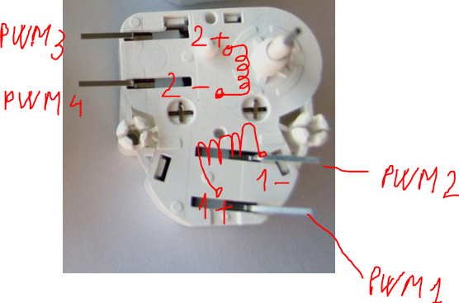
Declare the sine/cosine tables:
Sine_Table[128] = { 10, 18, 26, 34, 42, 50, 58, 66, 74, 84,
92, 102, 112, 124, 136, 148, 162, 176, 190, 202,
216, 226, 236, 242, 248, 250, 252 ,254, 254, 252,
252, 252, 252, 252, 252, 252, 252, 254, 254, 252,
252, 252, 250, 248, 246, 242, 238, 230, 222, 212,
198, 184, 166, 148, 130, 110, 92, 74, 58, 42,
30, 18, 8, 0, 10, 18, 26, 34, 42, 50,
58, 66, 74, 84, 92, 102, 112, 124, 136, 148,
162, 176, 190, 202, 216, 226, 236, 242, 248, 250,
252, 254, 254, 252, 252, 252, 252, 252, 252, 252,
252, 254, 254, 252, 252, 252, 250, 248, 246, 242,
238, 230, 222, 212, 198, 184, 166, 148, 130, 110,
92, 74, 58, 42, 30, 18, 8, 0 }
Cos_Table[128] = { 218, 222, 224, 228, 230, 234, 236, 238, 242, 242,
244, 244, 242, 238, 234, 226, 216, 202, 188, 170,
152, 130, 110, 90, 70, 52, 36, 20, 8, 4,
14, 22, 30, 38, 44, 50, 58, 64, 70, 74,
80, 86, 92, 98, 104, 110, 118, 126, 136, 144,
154, 164, 172, 180, 188, 194, 200, 202, 206, 208,
210, 212, 214, 216, 218, 222, 224, 228, 230, 234,
236, 238, 242, 242, 244, 244, 242, 238, 234, 226,
216, 202, 188, 170, 152, 130, 110, 90, 70, 52,
36, 20, 8, 4, 14, 22, 30, 38, 44, 50,
58, 64, 70, 74, 80, 86, 92, 98, 104, 110,
118, 126, 136, 144, 154, 164, 172, 180, 188, 194,
200, 202, 206, 208, 210, 212, 214, 216 }
Init :
Set all PWM duty cycles = 0
Set PWM period = 64 microseconds
Set Actual_Position = 0 and Target_Position = 0
/* Note1: the stepper consumes 35 mA per coil; be sure your controller does not get damaged
Note2: PWM resolution is considered to be 8-bit */
1ms_Container:
Set Target_Position to the desired value (0…5600 microsteps; 5600 ⬄ 315 degrees)
/* Note: be sure the motor does not run when you apply a new target position */
If Actual Position < Target Position
{
Actual_Position ++
}
If Actual Position > Target Position
{
Actual_Position - -
}
Tables_Index = Actual_Position%128
If Tables_Index < 32
{
Set PWM2_Duty = 0
Set PWM1_Duty = Sine_Table[Tables_Index]
Set PWM3_Duty = Cosine_Table[Tables_Index]
Set PWM4_Duty = 0
}
If (Tables_Index > 31) && (Tables_Index < 64)
{
Set PWM2_Duty = 0
Set PWM1_Duty = Sine_Table[Tables_Index]
Set PWM3_Duty = 0
Set PWM4_Duty = Cosine_Table[Tables_Index]
}
If (Tables_Index > 63) && (Tables_Index < 96)
{
Set PWM2_Duty = Sine_Table[Tables_Index]
Set PWM1_Duty = 0
Set PWM3_Duty = 0
Set PWM4_Duty = Cosine_Table[Tables_Index]
}
If (Tables_Index > 95) && (Tables_Index < 128)
{
Set PWM2_Duty = Sine_Table[Tables_Index]
Set PWM1_Duty = 0
Set PWM3_Duty = Cosine_Table[Tables_Index]
Set PWM4_Duty = 0 }

